MODULE 3

Que 1
https://www.hackerrank.com/challenges/for-loop-in-c/problem

Code
#include <stdio.h>
#include <string.h>
#include <math.h>
#include <stdlib.h>
int main()
{
int a, b;
scanf("%d\n%d", &a, &b);
for (int i = a; i <= b; i++) {
if (i >= 1 && i <= 9) {
char* reps[] = {"one", "two", "three", "four", "five", "six", "seven", "eight", "nine"};
printf("%s\n", reps[i - 1]);
} else {
if (i % 2 == 0) {
printf("even\n");
} else {
printf("odd\n");
}
}
}
// Complete the code.

return 0;
}

Output


Que 2
https://leetcode.com/problems/number-of-steps-to-reduce-a-number-to-zero/description/

Code
int numberOfSteps(int num) {
int steps = 0;
while (num > 0) {
if (num % 2 == 0) {
num /= 2;
} else {
num -= 1;
}
steps++;
}
return steps;
}

Output
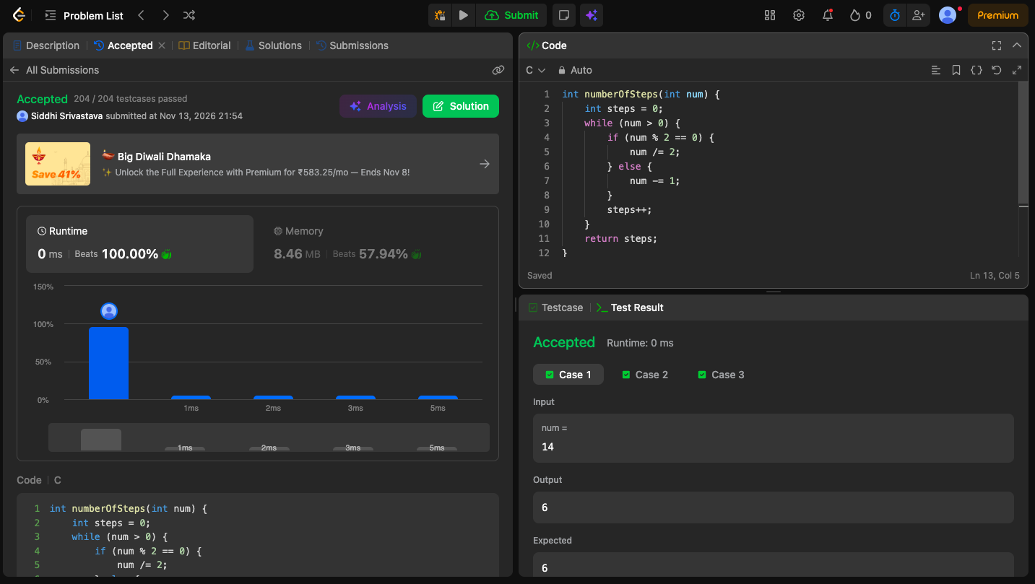

Que 3
https://leetcode.com/problems/count-operations-to-obtain-zero/description/

Code
int countOperations(int num1, int num2) {
int operations = 0;
while (num1 > 0 && num2 > 0) {
if (num1 >= num2) {
num1 -= num2;
} else {
num2 -= num1;
}
operations++;
}
return operations;
}

Output
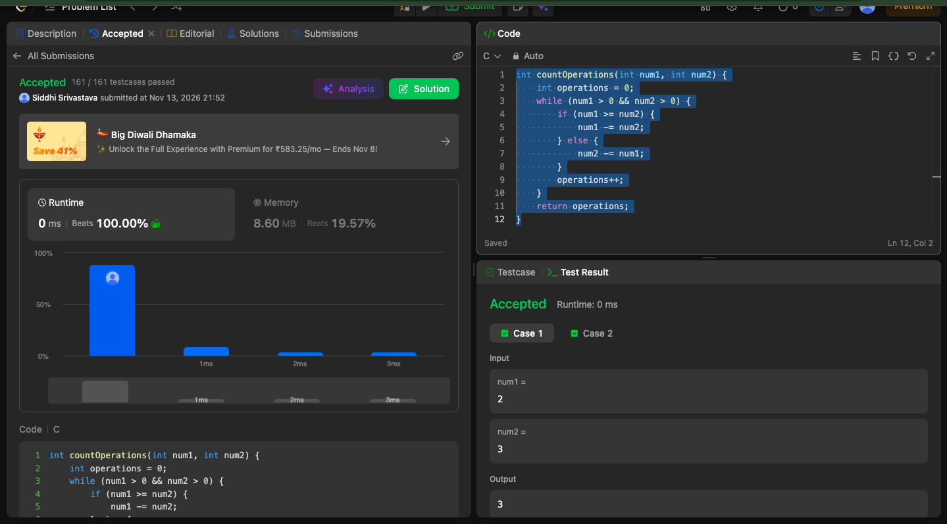

Que 4
https://leetcode.com/problems/count-odd-numbers-in-an-interval-range/

Code
int countOdds(int low, int high){
return (high + 1) / 2 - low / 2;

}

output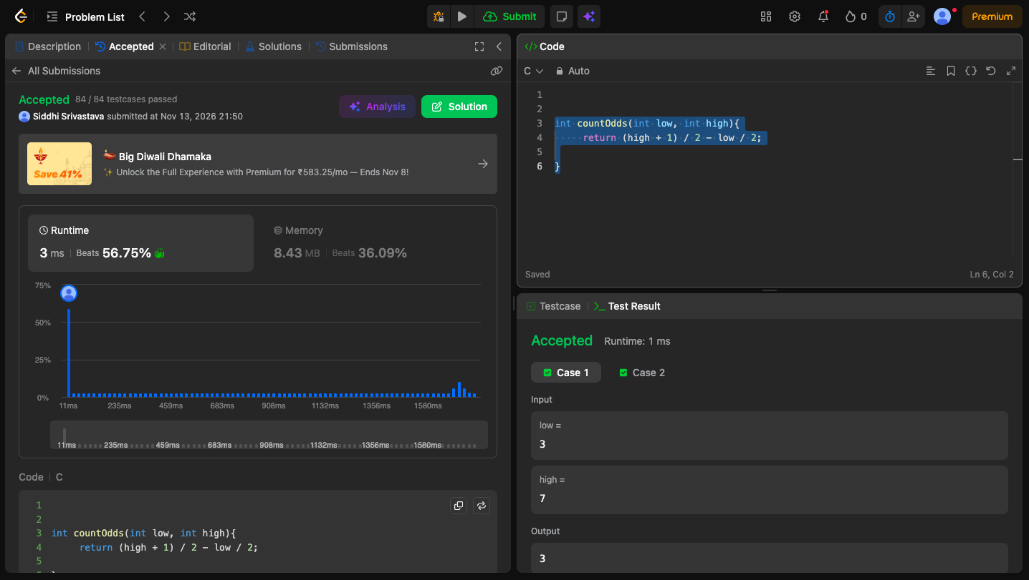

Que 5
https://leetcode.com/problems/sum-multiples/description/

Code
int sumOfMultiples(int n) {
int sum=0;
for (int i=1; i<=n ;i++)
{ if (i%3==0 || i%5==0 ||i%7==0)
sum+=i;}
return sum;
}

Output


